LBR5: AN OPTIMIZATION TOOL FOR PRELIMINARY SHIP DESIGN
and
CONLIN: A DUAL OPTIMIZATION ALGORITHM with CONVEX LINEARIZATION

–Handout prepared by Ph. Rigo(*) –

(*) ANAST, Dept. of Naval Architecture, University of Liege, Belgium (ph.rigo@ulg.ac.be),
(National Funds of Scientific Research of Belgium)

This handout explains why CONLIN (a general–purpose mathematical optimization algorithm) has been selected to solve our engineering problem (ship scantling optimization).

LBR5: AN OPTIMIZATION TOOL FOR PRELIMINARY SHIP DESIGN

The LBR–5’s purpose is to provide an optimum scantling of the central part of the ship (midship section) and the objective function is the least construction cost. As the LBR–5’s target is the preliminary design stage, heavy and time–consuming analysis does not fit with the LBR–5’s optimization framework.
Detailed information on LBR–5 are available in a series of papers published by Rigo (2001).

The normalized problem (primal problem) to solve is the following:
min [F(x_{i}) ] with N design variables x_{i} (scantling variables), (1)
F the objective function (Construction cost), (2)
subject to C_{j}(x_{i}) ≤ CM M constraints (structural constraints) (3)
x_{i min} ≤ x_{i} ≤ x_{i max} the lower–upper bounds (technologic constraints) (4)

Design variables:
Midship section can be easily modeled in stiffened panels that include plating, stiffeners and frames. Scantling of these panels corresponds to the selected (x_{i}) design variables (9 design variables per panels). In practice, a midship section can be modeled using 10 to 100 panels. So, our optimization problem concerns about 90 to 900 design variables).

Constraints:
Our wish is to design using rational formulations and not using empirical rules from Classification Societies. That means that most of the structural constraints are:
- Nonlinear: The relationships between design variables (x_{i}) and constraints (C_{j}) are nonlinear.
- Implicit: As stress analysis is performed to solve the governing differential equations of stiffened plates, the displacements and the stresses are obtained through a complex numerical process and there is no explicit equation between design variables (x_{i}) and constraints (C_{j}).
A treatment of the Finite Element Method (FEM) is not a goal here (preliminary design stage) but, to clarify the explanations, we can say that the constraints results from a numerical structural analysis similar to those preformed with usual finite element packages. It is therefore obvious that the number of re–analysis has to be limited (re–analysis means a new complete analyses of the structure with up–dated design variable values).
The number of constraints is usually about 10 for each panel. This means for a structure modeled with 100 panels and with 5 load cases, about 100x10x5=5000 constraints.

Objective functions:
Weight and construction cost, which is typically also based upon weight, are the available objective functions. These functions are simple compared to the constraints. They are explicit but sometimes nonlinear.

CONLIN: A DUAL OPTIMIZATION ALGORITHM with CONVEX LINEARIZATION

A dual approach with convex linearization was chosen as the mathematical optimization algorithm to be implemented with the LBR–5 software for various reasons. Before explaining the reasons for that choice, remember that we need an algorithm that:
- solves a problem including hundreds of design variables (500) and thousands of constraints (5,000),
- deals with highly nonlinear constraints,
- deals with implicit constraints.
And, above all, this algorithm must not need too much structure re–analysis (practical limit about 10).

Reasons of not choosing other methods:
- As the number of re–analyses has to be limited, methods using random generation of design variable values are discarded (Genetic algorithm, MonteCarlo simulation,…). For the same reason, methods having a low convergence level (1st order) cannot be selected (steepest gradient, conjugate gradient, etc.).
- Many efficient methods (Newton second order, SQP, etc.) use quadratic approximations and need the first and the second derivatives of the constraints and the objectives functions (called sensitivities). When complex structural analysis is used (FEM or LBR–5), it is hard and time consuming to get the sensitivities. For that reason, convex linearization are attractive as only the first derivatives are used.

To understand the other reasons of selecting CONLIN, we have to explain what is the convex linearization and what is a dual approach. These methods are presented in the next two sections.

CONLIN is an optimization technique developed by C. Fleury (1989, 93) using convex linearization of the constraints and objective function combined with in a dual approach. With this algorithm, large constrained problems with implicit and nonlinear constraints can be more easily solved (Figure 1).

The main difficulty in this optimization deals with the nonlinearities (1) and the constraints (2).

The nonlinearities: In order to avoid a large number of time–consuming re–assessments of the nonlinear and implicit functions, Fleury suggests applying convex approximations. At each iteration (sequential procedure), all the functions (objective function and constraints) are replaced by an approximation called “convex”. In a word, the complex initial optimization problem is decomposed into a sequence of more simple convex optimization problems (obtained through a convex linearization) that can be easily solved using a dual approach (Figure 1). So, using linearizations we replace the constrained nonlinear and implicit problem by a series of constrained linear and explicit problems.
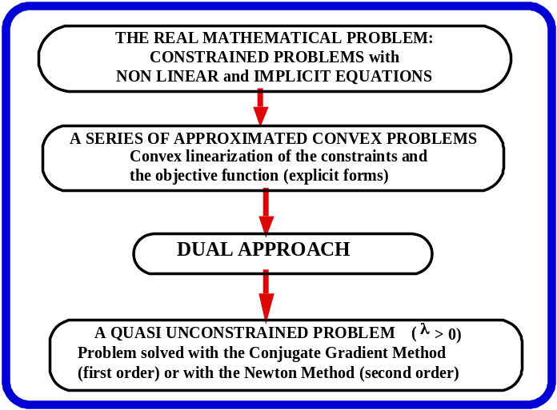

Figure 1. The CONLIN model:
Convex approximations and dual approach.

Constrained problem: The second difficulty is the fact that the problem is highly constrained. One alternative would be to use a penalty function to transform the constrained problem in an unconstrained one. The dual approach is a second alternative. We replace the primal constrained problem (N design variables, M constraints) by the dual quasi–unconstrained problem (M dual design variables and no constraint, except that the dual variables must be >0). For large FEM problems, usually N>> M. So, in addition of having an unconstrained problem, the equation system to solve is smaller in size. For LBR–5, many load cases are considered, so we have N<M and we do not get advantage of the fact that the dual problem has less design variables than the primal problem.

In conclusion, using both convex linearization and the dual approach, we replace the constrained nonlinear and implicit problem by a quasi–unconstrained linear and explicit problem that can be solved using the conjugate gradient method or second–order Newton method.

CONLIN is a sequential approach. There is an external loop that requires structural re–analysis of the structure with the current values of the design variables. In this loop, the constrained nonlinear and implicit problem is replaced by an approximated, quasi–unconstrained, linear and explicit problem (convex linearization and the dual approach). Then, in the interior loop, the dual problem is used to solve the approximated problem using a standard algorithm for unconstrained optimization. This latter problem being explicit, no matter of the number of steps to get the solution of the approximated problem, it only requires tenths of second. The solution of the approximated problem (inner loop) is used for the next external iteration.

Practical advantages of CONLIN:
- Convergence is guaranteed to be within the feasible space. This means that, at each iteration, the solution is feasible. This is very important for the engineering application. The optimization procedure can be stopped at any time and the solution is feasible and better then the initial point,
- Optimum solution is found within 10 to 15 iterations even for large problems (convergence = order 2),
- The Initial design point needs not be in the feasible space. First iterations (1 or 2) are used to move inside the feasible space (no matter of the objective function) and than optimization is performed,
- The method is robust. “Relaxation” can be used if the convergence fails. Up to now, such a problem has never occured using LBR–5.

CONVEX LINEARIZATION

In order to handle nonlinear implicit constraints (C(x_{i})), Fleury proposes replacing these constraints with approximated explicit linear constraints by using convex linearization. He suggests using the first term of the Taylor Series Expansion. Three linear alternatives are possible:
• Linearization with standard design variables (x_{i} , i=1,N) :
(5)

• Linearization with reciprocal design variables (1/x_{i} , i=1,N) :
(6)

• Convex linearization with mixed variables (x_{k} , k=1,L) and (1/x_{j} , j=L+1,N)
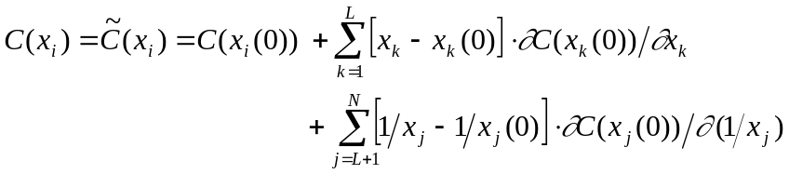 (7)
As design variables refer to dimensions such as plate thickness, web height, etc., it is not suitable to use x_{i} to linearize constraints related to stress, strength and displacement. It is better to use reciprocal linearization (1/x_{i}). On the other hand, geometrical constraints (for instance: “w – h ≤ 0”, with h the web height and w the flange width) must be linearized with standard design variables (x_{i}) instead of reciprocal ones (1/x_{i}). Therefore, for a general case, it is obvious that mixed linearization will occur. But the problem remains how to determine which linearization is the most suitable (reciprocal variable 1/x or direct variable x) for each design variable. C. Fleury has responded to this, proposing to make this selection in a way that replaces the actual design space (feasible domain for the design variables) by a smaller domain, included in the actual one, but convex (Figure 2). One can summarize in this way: since the substitution design space is conservative, this leads to a solution that is still admissible, but that could be "slightly" different from the real optimum. Step by step, this conservatism is released as one comes closer to the real optimum.
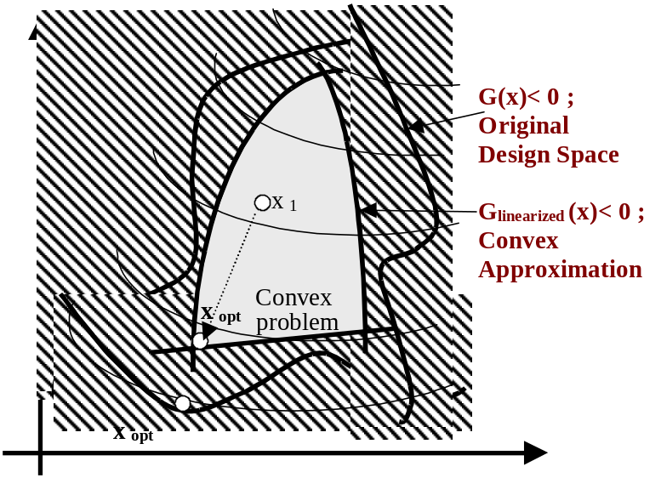

Figure 2. Convex linearization of the feasible space.

The convexity of the design space and conservatism allow a safe and fast convergence. The convergence is safe because, at each iteration, the updated solution has a tendency to still remain in the feasible domain. Fleury has demonstrated that an efficient convex linearization can be achieved by selecting the group of variables (x_{i}) and the group of reciprocal variables (1/x_{i}) according to the sign of the first derivative of the function to linearize, that is ∂C(x_{i}(0))/∂x_{i}.
For a given design variable x_{i} :
- a linearization with standard variable x_{i} is achieved if ∂C(x_{i}(0))/∂x_{i} > 0 ;
- a linearization with reciprocal variable 1/x_{i} is performed if ∂C(x_{i}(0))/∂x_{i} < 0.

Therefore, Eq.(3) becomes:

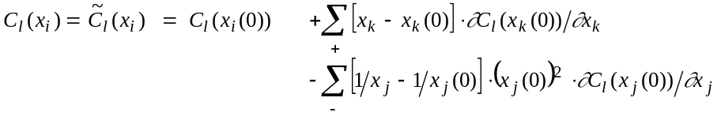 (8)
with ∂C(x_{k}(0))/∂x_{k} > 0 (1 ≤ k ≤ L≤ N) ; ∂C(x_{j}(0))/∂x_{j} < 0 (L+1 ≤ j ≤ N), for i=1,N and l=1,M.

The proposed convex linearization is very "user friendly" as only the values of C(x_{l}(0)) and ∂C(x_{k}(0))/∂x_{k} are required. The linearization is done automatically at each step (iteration) and the convergence order is 2. In addition, the main advantage of the proposed convex linearization is the conservatism of the approximated function. Let's note, however, that conservatism is only guaranteed with regards to initial linear functions in x_{k} and in 1/x_{j}. To avoid numerical problem the equations have to be normalized before starting the convex linearization. Fleury (1987, 1993) explains this procedure
As an example (Figure 3), consider the C1 and C2 constraints (eq.(9a) and eq.(9b)) and some feasible linearizations (eq.(9c) to eq.(9f)):
C1(x) = 5 x₂ – x₁² – 10 ≤ 0 (9a)
C2(x) = 5/4 x₂² + 16 / x₁² – 13 ≤ 0 (9b)

The considered initial point of the design variables is x(0)=(x₁, x₂)=(2,2). At this point, the two constraints and their first derivatives are the same as:
C1(2,2) = C2(2,2) = – 4 and
∂C1(2,2)/∂x = ∂C2(2,2)/∂x = (– 4 , 5).

Based on these equalities, all the linearized equations of C1 and C2 [eqs.(9c–9f)] are the same. According to the linearization models [eqs.(5–8)], we obtain for both C1 and C2:
• Standard linearization, x [eq.(5)]: 5 x₂ – 4 x₁ – 6 ≤ 0 (9c)
• Reciprocal linearization, 1/x [eq.(6]: – 20/x₂ + 16/x₁ – 2 ≤ 0 (9d)
• Convex linearization [eq.(8)]: 5 x₂ + 16/x₁ – 22 ≤ 0 (9e)
The variables are: x₂ as ∂C/∂x₂ = 5 > 0
1/x₁ as ∂C/∂x₁ = – 4 < 0
• Concave linearization, with x₁ and 1/x₂ 5 x₂ + 16/x₁ – 22 ≤ 0 (9f)

Figure 3 shows that the convex linearization [eq.(9e)], is the best linearization and the most conservative way, even if it fails with regards to C2, which is initially more convex (a quadratic function in x₂ and 1/x [eq.(9b)]) than the approximated convex function (a linear function in x₂ and 1/x₁ [eq.(9e)]).
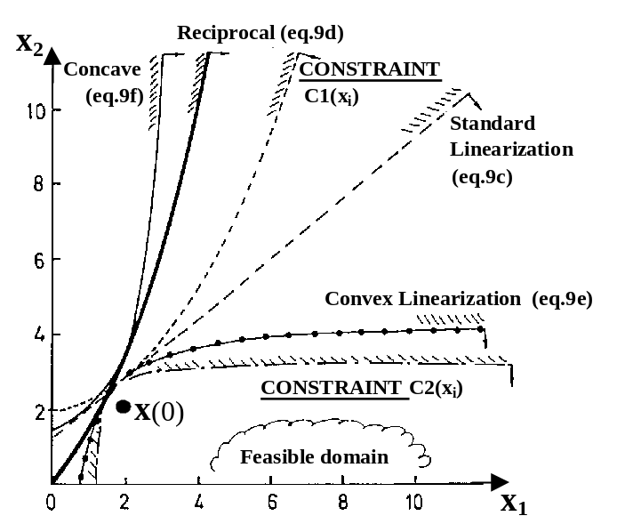

Figure 3. Comparison between different linearizations.

Example 1:
C(x) = 5 x₂ – x₁² – 10 ≤ 0 (9a)

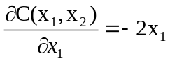 and 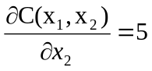
Linearization at x⁰ = (x₁, x₂) = (2,2)
∂C(x⁰)/∂x₁ = – 4 (negative value → convex linearization using the 1/x₁ variable)
∂C(x⁰)/∂x₂ = + 5 (positive value → convex linearization using the x₂ variable)

- Convex linearization using 1/x₁, x₂ as variables
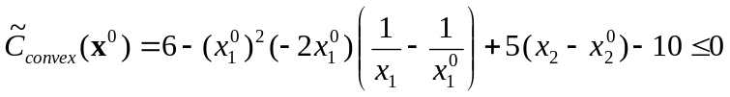
as 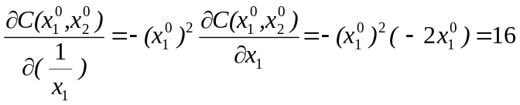
then we obtain (eq.9e): 5 x₂ + 16/x₁ – 22 ≤ 0

- Standard linearization using x₁, x₂ as variables
then we obtain (eq.9c): 5 x₂ – 4 x₁ – 6 ≤ 0

Example 2 (Figure 4):

The original Problem The convex & linearized subproblem
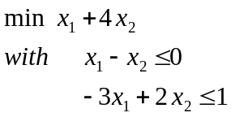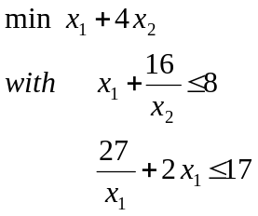
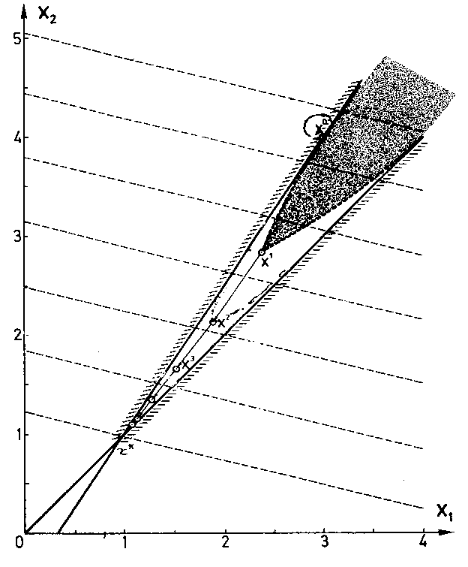

Figure 4: Convergence Process using Convex Linearization
A DUAL ALGORITHM FOR OPTIMIZATION PROBLEM

- At each iteration, the normalized problem to solve (after convex linearization) is the following:
min [Σ F_{j} / x_{j} – Σ F_{i} . x_{i} ] with N design variables x_{i} , i=1,N
subject to M constraints: Σ C_{jk} / x_{j} – Σ C_{ik} . x_{i} ≤ CM , k=1,M
and x_{i min} ≤ x_{i} ≤ x_{i max} the lower–upper bounds.

This problem is called a primal problem with reference to the x_{i} design variables, called primary or primal design variables. It is a constrained problem with N design variables and M constraints. This problem cannot be solved easily with classic methods such as, for example, the Conjugated Gradient. A dual approach will be used here to replace the primal constrained problem with N unknowns by an unconstrained problem with M unknowns (called the dual problem). This technique is especially advantageous when M << N. Unfortunately, with regard to the applications considered in this paper, this last advantage is not relevant since M > N when multiple load cases are considered.

- To the primal problem (convex with separable variables), one can associate the dual problem:
max(λ) [ min(x) de L(x,λ) ] and x_{i min} ≤ x_{i} ≤ x_{i max}
with L(x,λ) the Lagrangian,
λ_{k} the M Lagrange multipliers (dual variables)
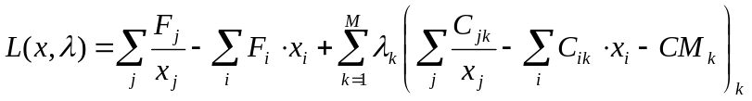 (10)
which is also a function with separable variables.

Because the Lagrangian is separable [eq.(10)], the single dual problem with N design variables (N dimensions) is replaced by a series of N problems with a single dimension:

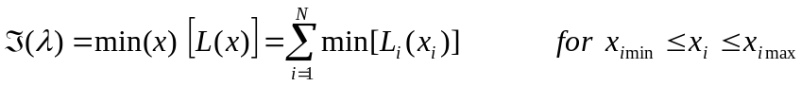 (11)
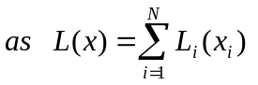 (As function with separable variables)

Each term of the L(x) minimization [eq.(10)] can be written in an explicit form:
min[ L_{i}(x_{i}) ] = A_{i} x_{i} + B_{i} / x_{i} where A_{i} and B_{i} are defined as: 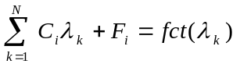 (12)

Note that the minimization related to each x_{i} variable requires that ∂L_{i}/∂x_{i} = 0. Then,
(13)

REFERENCES

Fleury C., Braibant V. (1986), “Structural Optimization: A New Dual Method using Mixed Variables”, International Journal for Numerical Methods in Engineering, Vol.23, pp 409–428.
Fleury C. (1989). “CONLIN, An Efficient Dual Optimizer Based on Convex Approximation Concepts”, Structural Optimization, Vol. 1, pp 81–89.
Fleury C. (1993), “Mathematical Programming Methods for Constrained Optimization: Dual Methods”, (Chap. 7) and “Recent Developments in Structural Optimization Methods” (Chap. 9)’ in Structural Optimization: Status and Promise, (M.P. Kamat ed.), Series: Progress in Astronautics and Aeronautics, AIAA, Vol.150, pp. 123–150 and 183–208.
Rigo Ph. (2001), “A Module-Oriented Tool for Optimum Design of Stiffened Structures”, Marine Structures, Elsevier Science Ltd., vol 14/6, pp611-629
Rigo Ph., Fleury C. (2001), “Scantling Optimization based on Convex Linearization and a Dual Approach”, Marine Structures, Elsevier, vol 14/6, pp631-649
Rigo Ph. (2001), “Least-Cost Structural Optimization Oriented Preliminary Design”, Journal of Ship Production, USA, vol.17/4, pp.202-215
Rigo Ph. (2003), “An Integrated Software for Scantling Optimization and Least Production Cost”, Ship Technology Research, Schiffahrts-Verslag “Hansa”, vol.50, pp.126-141

G(x)< 0 ; Original Design Space

G_{linearized}(x)< 0 ; Convex Approximation
X₁
X_{opt} (Convex Problem)
X_{opt}
